**Exercise**

1. import java.util.Scanner;

import java.util.regex.*;

class Main

{

public static void main (String[] args) {

String date;

Scanner s=new Scanner(System.in);

date=s.nextLine();

Main m=new Main();

System.out.println(m.isValid(date));

}

String isValid(String date)

{

int flag;

if(date.matches("dd-MM-yyyy"))

{

flag=1;

}

else

{

flag=0;

}

if(flag==1)

return "Valid";

else

return "Invalid";

}

}

**Output:**

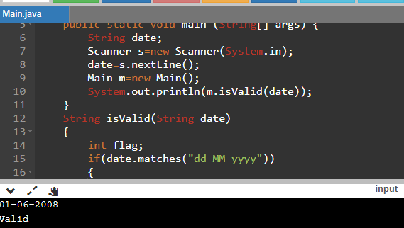

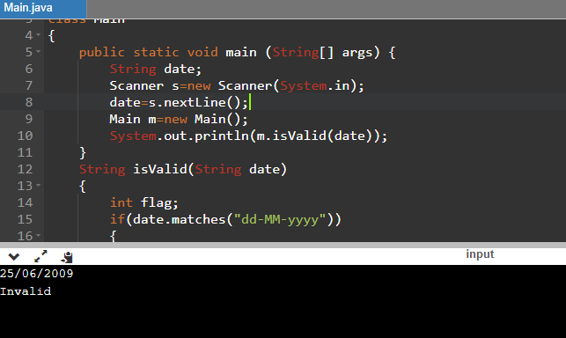

1. import java.util.Scanner;

import java.util.regex.*;

class Main

{

public static void main (String[] args) {

String city;

Scanner s=new Scanner(System.in);

city=s.nextLine();

Main m=new Main();

System.out.println(m.isValid(city));

}

String isValid(String city)

{

int flag;

if(city.matches("[a-zA-Z]{2}[*]+[a-zA-Z]{2}"))

{

flag=1;

}

else

{

flag=0;

}

if(flag==1)

return "Valid";

else

return "Invalid";

}

}

**Output:**

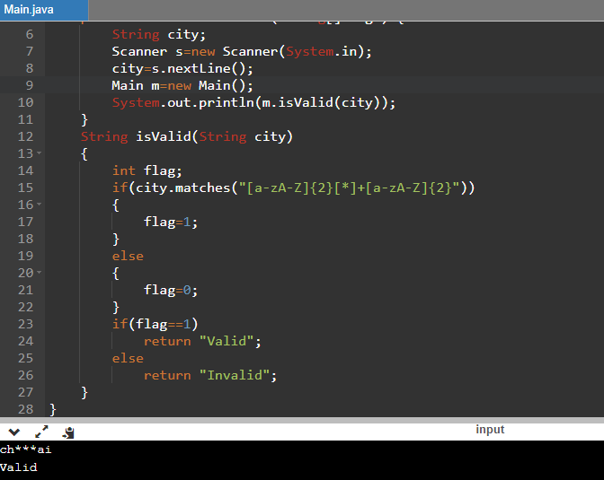

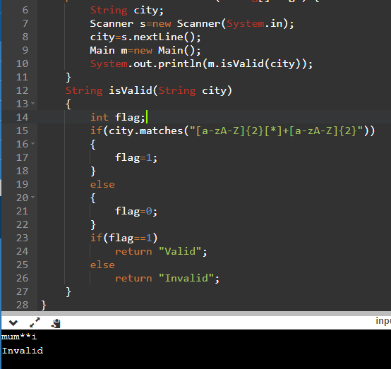

1. import java.util.Scanner;

import java.util.regex.*;

class Main

{

public static void main (String[] args) {

String name;

Scanner s=new Scanner(System.in);

name=s.nextLine();

char[] input=name.toCharArray();

Main m=new Main();

int len=name.length();

boolean n=m.validatePlayer(input,len);

if(n==true)

System.out.println("Valid");

else

System.out.println("Invalid");

}

boolean validatePlayer(char[] input,int len) {

for(int i=1;i<len;i=i+2) {

if(input[i]=='a')

{

return false;

}

}

return true;

}

}

**Output:**

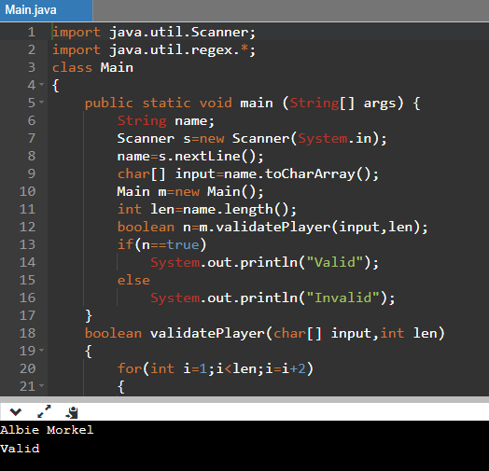

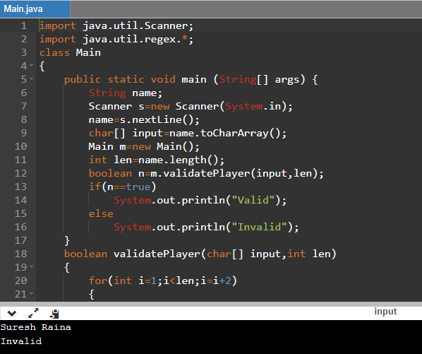

1. import java.util.Scanner;

public class Main {

public static void main (String[] args)

{

float a,b,area = 0;

char choice;

Scanner input = new Scanner(System.in);

System.out.println("shape Menu\n1.Rectangle\n2.Square\n3.Circle\nArea calculator choose your shape correct/exit\nType r or s or c\n");

String s = input.next();

choice = s.charAt(0);

switch(choice)

{

case 'r':

System.out.println("Enter length and breadth:");

a = input.nextFloat();

b = input.nextFloat();

area = a*b;

break;

case 's':

System.out.println("Enter side:");

a = input.nextFloat();

area = a*a;

break;

case 'c':

System.out.println("Enter radius:");

a = input.nextFloat();

area = 3.14f*a*a;

break;

default:

System.out.println("Error");

}

System.out.println("Area = "+area);

}

}

**Output:**

